# Change request log

# Team

Group #5 (Inam and Pervez)

# Change Request

FEMR-158: If an administrator tries to edit a user, the "Change User Password" input fields are required and a notification gets sent back that the "password field is empty".

# Concept Location

Below table is to describe each step that we followed when performing concept location for this change request.

|  |  |  |
| --- | --- | --- |
| Step # | Description | Rationale |
| 1 | We ran the system |  |
| 2 | We interacted with the system: after logging in we click the admin tab then left side Users tab and hit the edit for any user on the screen. It appears edit screen. When we change any column value and keep password change box empty. We got error “password field is empty” | In order to get familiar with some of the features of the system, and identify the screens or graphical elements we had to change. |
| 3 | Though it is a bug in a particular screen in UI  We searched for "Edit User view" in UI folder using the regular expression feature of the IDE's search tool. | Because we identified an “Edit users” screen in Change User Password field. |
| 4 | From search results, we got Edit View model class under “users” folder using the Structure window of the IDE. |  |
| 5 | We inspected the class EditViewModel  and under that class, we got one list method called validate(). | We noticed that the method has validation logic for “Edit User” screen all fields. |
| 6 | We saw a validation for empty fields, which are required to be filled by user. | If fields are empty, it throw exception “Password fields are required to be filled” |
| 7 | We change the logic and un comment the password field validation. | We ran the code in debug mode and verify all the changes that we made. |

**Time spent (in minutes):** 200

# Impact Analysis

|  |  |  |
| --- | --- | --- |
| Step # | Description | Rationale |
| 1 | We made changes in a method of the “EditViewModel” class. | EditViewModel validates the password fields, which are required to be filled. |
| 2 | On changing the method, there were no errors in the classes which means there is no impact for this change or no other classes called this method. | There is no impact for this change. |
| 3 | This method can be use in other classes since, it will not validate the password empty fields. |  |
| 4 | This method(EditViewModel) is called by the Usercontroller, and is execute by the action of fields.scala.html | No impact on UserController Class. |

**Time spent (in minutes):** 60

# Actualization

Using the table below, describe each step you followed when changing the code. Include as many details as possible, including why classes/methods were modified, added, removed, renamed, etc.

|  |  |  |
| --- | --- | --- |
| Step # | Description | Rationale |
| 1 | We modified one method | We realized that class Editviewmodel has validate() method and we just remove password Empty if condition from that method. |
| 3 | We created unit tests for the new class and also performed functional testing. We also ran the existing test cases. | To make sure everything works. |

**Time spent (in minutes):** 75

# Validation

Using the table below, describe any validation activity (e.g., testing, code inspections, etc.) you performed for this change request. Include the description of each test case, the result (pass/fail) and its rationale.

|  |  |  |
| --- | --- | --- |
| Step # | Description | Rationale |
| 1 | Test case defined:  Inputs: Two password field empty  Expected output : User updated successfully | This is main regular requirement to check, user can update user information without password field to be filled.  The test passed. |
| 2 | Test case defined:  Inputs: one password has value and other is empty  Expected output: Password filed validation, screen will revoke to save the user information. | This is an exceptional behavior, will perform the password field validation  The test passed. |
| 3 | Test case defined:  Inputs: both password has values (accurate to the validation).  Expected output: Password filed validation passed and user information is updated. | This is main regular requirement to check, user can update user information with password field validation.  The test passed. |
| 4 | Test case defined:  Inputs: both password has values ( not accurate to the validation).  Expected output: Password filed validation user revoke to update the user information. | This is an exceptional behavior, will perform the password field validation  The test passed. |

**Time spent (in minutes):** 60

# Timing

Summarize the time spent on each phase.

|  |  |
| --- | --- |
| Phase Name | Time (in minutes) |
| Concept location | 31 |
| Impact Analysis | 60 |
| Prefactoring | 0 |
| Actualization | 75 |
| Postfactoring | 0 |
| Verification | 60 |
|  |  |
| Total | 226 |

# Reverse engineering

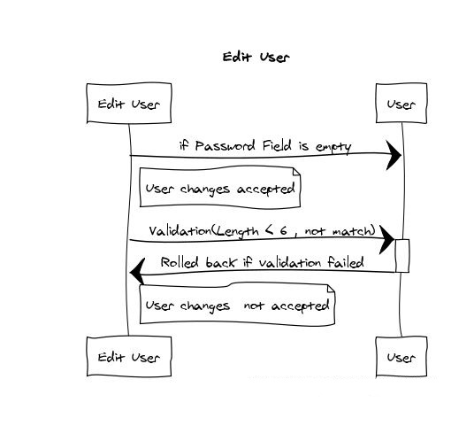

# Conclusions

Before the change the screen didn’t allow to edit the user information if the password field is empty.

Now after change impact now user can edit the user information if the password field is an empty. This change didnt give any change impact on other classes, i-e the validation and verification works perfectly fine and vice versa is the classes.

Regarding this fix, we change below method from UI Editviewmodel class and there is no anywhere we used that method.

\workspace\femr\app\femr\ui\models\admin\users\EditViewModel.java

public List<ValidationError> validate()